Proyecto de cargador solar de baterías usando LM317

Objetivo utilizar este prototipo para alimentar proyectos de microcontroladores donde se desea autonomía (baterías recargadas con energía solar)

Simple LM317 Solar Charger for 12V batteries
Jun 25th, 2012 by Alex
I’ve had a small solar panel now with a voltage of up to 18V (up to 83mA current) for a little while so it’s now time to make a small solar power charger to recharge 12V batteries. Previously I had a solar panel with a voltage of up to 14V which didn’t cut it when the sun was shinning on it for a few minutes; I found the voltage dropped and it wasn’t enough to recharge my 12V batteries.
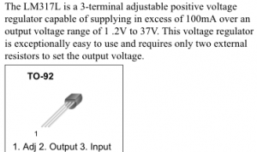
I chose to use the LM317 regulator as it seems to be a common regulator to use for small current devices. With the LM317 you can adjust the output voltage ranging from 1.2V to 37V by using 2 resistors on the adjust pin.
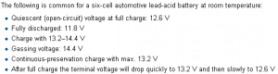
The primary use of this charger is to keep my 12V batteries topped up. From Wikipedia we find that voltage to keep batteries topped up is called the Continuous-preservation charge which is 13.2V.
Before we go and set the LM317 output voltage to 13.2V we need to include a diode on the output to protect the battery from supplying voltage to the LM317 when the sun isn’t shinning and it will also protect us against a short circuit between input and ground. Now because we have a diode on the output, we could easily add more batteries to keep topped up by adding a diode to each battery.
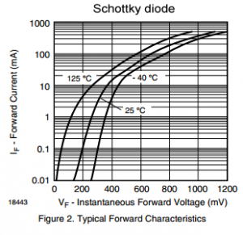
I chose a schottky BAT42 diode and you see a 0.15V drop at 3uA (tested) and then it increases to 0.7V at 100mA.
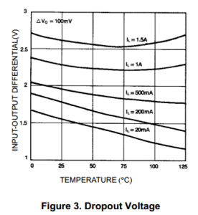
The output voltage of the LM317 will be 13.2V + 0.7V (worst case) = 13.9V. The LM317 has a drop out voltage of 1.75V @ 100mA so we require minimum input of 15.75V but we’ll round that up to 16V.
To calculate which resistors to use there is a LM317 Voltage Calculator website that can help us out.
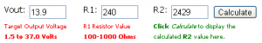
The R1 common resistor value to use is 240ohms and the R2 value is 2429ohms which we can round up to a 2.43K resistor.
Now we just need to calculate the power dissipation, let’s say 20V is our maximum input, we drop to 13.2V. The drop on the regulator is 6.8V and say my solar panel outputs 80mA so it’s 0.544mW which is lower than the 625mW of the TO-92 package so we are all good.
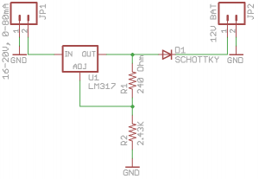
Above is our schematic and PCB, download here: Simple_LM317_Solar_Charger_v1.0
After leaving a 12V car battery and a 12V sealed battery on for a 2-3days, it recharged the battery voltage to 12.35V which gives us about 75% capacity according to Wikipedia, so it seems to work good enough.

Simple LM317 Solar Charger
Jul 29th, 2012 by Alex
A simple solar charger for 12V batteries to keep them topped up and based on the LM317. View the post explaining the circuit here.
Specifications
PCB board: 17.35mm x 11.2mm
Input Voltage: 16V to 20V
Input current rating: Up to 80mA
Output voltage (no load): 13.65-14.1V (ideally 13.7V)
Output voltage (2mA load): 13.35-13.85V
Output voltage (10mA load): 13.25-13.75V
Output voltage (50mA load): 13-13.45V

Download
v1.0 (23 June 2012) – Download
- Initial Release

Build your own
Parts Required
- LM317 TO-92 (1) – LM317LZ – [Q1]
- 240 Ohm Resistor 1/4W 1% (1) – [R1]
- 2.43K Resistor 1/4W 1% (1) – [R2]
- Schottky Diode DO-35 (1) – BAT42 – [D1]
- Female headers (2)
Schematic
PCB Guide
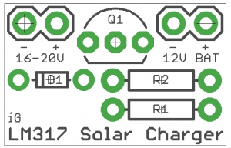
PCB Ready for etching
